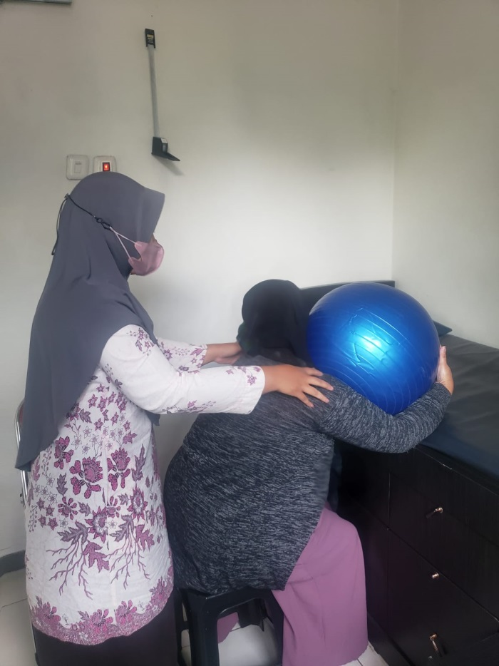

# PERSETUJUAN ETIK

## Ethical Approval

Nomor: 004/KEPK/VIII/2023

Komisi Etik Penelitian Kesehatan STIKES Guna Bangsa Yogyakarta telah melakukan kajian terhadap prinsip etik yang dilandasi studi kepustakaan dalam upaya melindungi subjek penelitian kesehatan. Usulan penelitian telah disetujui dan dinyatakan layak etik dengan judul:

# “Efektifitas Teknik Endorphine Massage Terhadap Intensitas Nyeri Pada Ibu Bersalin Kala I Fase Aktif”

*The Health Research Ethics Commission of The College of Health Sciences of Guna Bangsa Yogyakarta has conducted an assessment of ethical principles based on library studies to protect health research subjects. The research proposal has been approved and appropriate for ethics with the title:*

## “The Effectiveness of Endorphine Massage Technique on Pain Intensity in Active First Stages of Labor”

Nama Peneliti : Yesti Aprilia Ambarwati

*Name of Researcher*

NIM/NIDN Peneliti : 220831063

*Student number/main number of researcher*

Asal Institusi : [STIKES Guna Bangsa Yogyakarta](https://www.unisayogya.ac.id/id/)

*Institution*

Ditetapkan di: Yogyakarta

Issued in

Tanggal.: 1 Agustus

Date. 2023



Ketua

Chairperson

Dr. Fatimah Sari, S. Si. T., Bd., M. Kes

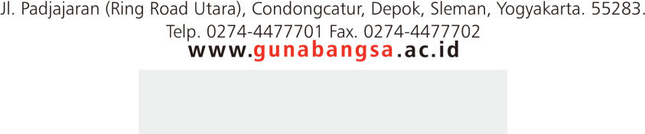

1. Instrumen
2. SOP Endorphine Massage

|  |  |
| --- | --- |
| **A.** | **Fase Orientasi** |
| 1. | Mengucapkan salam dan memperkenalkan diri |
| 2. | Menjelaskan tujuan tindakan |
| 3. | Menjelaskan langkah prosedur |
| 4. | Menanyakan kesiapan |
| 5. | Kontrak waktu |
| **B.** | **Fase Kerja** |
| 1. | Anjuran ibu untuk mengambil posisi senyaman mungkin, bisa dilakukan dengan duduk, atau berbaring miring. Perawat untuk duduk dengan nyaman  di samping atau dibelakang ibu. |
| 2. | Anjurkan ibu untuk bernafas dalam, sambil memejamkan mata dengan lembut untuk beberapa saat. Setelah itu perawat mulai mengelus permukaan luar lengan ibu, mulai dari tangan sampai lengan bawah. Belaian ini sangat lembut dan dilakukan dengan menggunakan jari-jemari atau hanya ujung-  ujung jari. |
| 3. | Setelah kira-kira lima menit, berpindah ke lengan yang lain. Walaupun sentuhan ringan ini dilakukan di kedua lengan ibu, ibu akan merasakan bahwa dampaknya sangat menenangkan di sekujur tubuh. Teknik ini juga bisa diterapkan dibagian tubuh lain, termasuk telapak tangan, leher, dan  bahu, serta paha. |
| 4. | Teknik sentuhan ringan ini sangat efektif jika dilakukan di bagian punggung. Caranya, ibu dianjurkan untuk berbaring miring, atau duduk. Dimulai dari leher, memijat ringan membentuk huruf V kearah luar menuju sisi tulang rusuk. Massagean-massagean ini terus turun kebawah, kebelakang. Ibu  di anjurkan untuk rilaks dan merasakan sensasinya. |
| 5. | Perawat dapat memperkuat efek menegangkan dengan mengucapkan kata-  kata yang menentramkan saat dia memijat dengan lembut. |
| 6. | Merapikan pasien dan alat |
| **C.** | **Fase Terminasi** |
| 1. | Evaluasi hasil |
| 2. | Rencana tindak lanjut |
| 3. | Dokumentasi |

1. Wong Baker Rating Scale dalam Lembar Observasi

**LEMBAR OBSERVASI**

Efektifitas Teknik *Endorphine Massage* Terhadap Intensitas Nyeri pada Ibu Bersalin Kala I Fase Aktif di UPTD Puskesmas Bumijawa, Kab.Tegal-Jateng.

Data demografi

1. Nama :
2. Umur :
3. G/P/A :
4. Pendidikan :
5. Pekerjaan :
6. Alamat :

**Petunjuk :**

Berilah tanda silang (x) pada nomer/Skala yang sesuai dengan intenstas nyeri yang dirasakan.

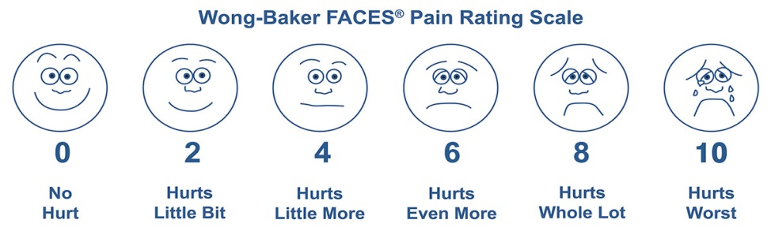Pengkajian Nyeri Berdasarkan Skala Nyeri Wong-Baker Faces.

1. Sebelum diberikan Intervensi

|  |  |  |  |  |  |  |  |  |  |  |
| --- | --- | --- | --- | --- | --- | --- | --- | --- | --- | --- |
| 0 | 1 | 2 | 3 | 4 | 5 | 6 | 7 | 8 | 9 | 10 |

1. Sesudah diberikan Intervensi 15 menit (Teknik Endorphine Massage)

|  |  |  |  |  |  |  |  |  |  |  |
| --- | --- | --- | --- | --- | --- | --- | --- | --- | --- | --- |
| 0 | 1 | 2 | 3 | 4 | 5 | 6 | 7 | 8 | 9 | 10 |

Keterangan dan panduan pengisian :

a. (0) : Tidak Nyeri

b. (2) : Sedikit Nyeri

c. (4) : Sedikit Lebih Nyeri

d. (6) : Nyeri sekali

e. (8) : Sangat Nyeri

f. (10) : Nyeri Sangat Berat

**Petunjuk Penggunaan penilaian 3, 5, 7, 9**

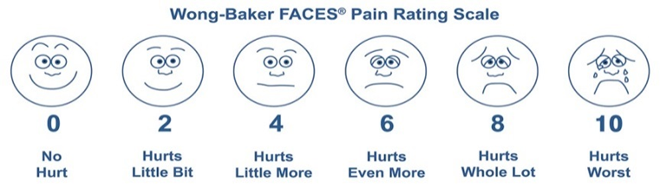

Jelaskan kepada pasien bahwa setiap wajah mewakili seseorang yang tidak merasakan sakit (sakit), atau sedikit, atau sangat sakit.

Dengan keterangan pengisian pada lembar Observasi sebagai berikut:

Wajah 0 tidak nyeri.

**Penilaian 0-1 masih dapat tersenyum**

Wajah 2 hanya sedikit nyeri. (selalu dapat tersenyum)

**Penilaian 3 untuk yang masih dapat tersenyum tetapi terkadang merasakan sedikit lebih nyeri,**

Wajah 4 sedikit lebih nyeri. (bibir sudah tidak dapat tersenyum)

**Penilaian 5 untuk yang sudah tidak dapat tersenyum dan terkadang merasakan Nyeri Sekali,**

Wajah 6 Nyeri Sekali. (sudah berekspresi masam dan tidak ada lagi senyum)

**Penilaian 7 untuk yang sudah berekspresi masam tidak dapat tersenyum dan terkadang merasakan sangat nyeri,**

Wajah 8 sangat nyeri. (berekspresi sudah tidak masam melainkan hampir menangis)

**Penilaian 9 untuk yang merasakan nyeri sekali terkadang merasakan sangat nyeri ingin menangis dan nyeri yang terburuk,**

Wajah 10 nyeri sangat berat seperti yang dapat Anda bayangkan, meskipun Anda tidak perlu menangis untuk merasakannya akan tetapi ini adalah rasa nyeri terburuk.

**Pilihlah wajah yang paling menggambarkan rasa sakit yang saat ini anda alami.**

1. Gambar dan data sekunder penelitian

Responden Kelompok Eksperimen

| **NO** | **NAMA PASIEN** | **USIA** | **PARITAS** | | |
| --- | --- | --- | --- | --- | --- |
| **PRIMIPARA** | **MULTIPARA** | **GRANDEMULTIPARA** |
|
| 1 | N | 20 | G1POA0 |  |  |
| 2 | F | 28 |  | G3P1A1 |  |
| 3 | K | 29 |  | G2P1A0 |  |
| 4 | R | 42 |  |  | G5P3A1 |
| 5 | S | 39 |  |  | G4P3A0 |
| 6 | K | 31 |  | G3P2A0 |  |
| 7 | S | 22 |  | G2P1A0 |  |
| 8 | M | 46 |  |  | G4P3A0 |
| 9 | M | 35 |  | G2P1A0 |  |
| 10 | E | 24 |  | G3P1A1 |  |
| 11 | N | 32 |  | G2P1A0 |  |
| 12 | Fe | 18 | G1POA0 |  |  |
| 13 | P | 40 |  |  | G4P1A1 |
| 14 | T | 32 | G1POA0 |  |  |
| 15 | K | 42 |  |  | G5P4A0 |
| 16 | A | 20 | G1POA0 |  |  |
| 17 | D | 26 | G1POA0 |  |  |
| 18 | R | 33 | G1POA0 |  |  |
| 19 | T | 23 | G1POA0 |  |  |
| 20 | S | 34 |  | G2P1A0 |  |
| 21 | K | 38 |  | G3P2A0 |  |
| 22 | M | 37 |  | G2P1A0 |  |
| 23 | N | 39 |  | G3P2A0 |  |
| 24 | N | 22 | G1POA0 |  |  |
| 25 | R | 26 |  | G2P1A0 |  |
| 26 | A | 24 |  | G3P2A0 |  |
| 27 | Y | 22 | G1POA0 |  |  |
| 28 | D | 22 |  | G2P0A1 |  |
| 29 | S | 24 |  | G2P1A0 |  |
| 30 | E | 35 |  | G3P2A0 |  |

Responden Kelompok Kontrol

| **NO** | **NAMA PASIEN** | **USIA** | **PARITAS** | | |
| --- | --- | --- | --- | --- | --- |
| **PRIMIPARA** | **MULTIPARA** | **GRANDAMULTIPARA** |
|
| 1 | L | 24 |  | G2P1A0 |  |
| 2 | A | 30 |  | G3P2A0 |  |
| 3 | R | 19 | G1P0A0 |  |  |
| 4 | S | 33 |  |  | G4P3A0 |
| 5 | R | 44 |  |  | G5P2A2 |
| 6 | N | 20 |  | G2P1A0 |  |
| 7 | Z | 24 |  | G2P1A0 |  |
| 8 | L | 23 |  | G2P0A1 |  |
| 9 | S | 22 |  | G2P1A0 |  |
| 10 | N | 29 |  | G3P2A0 |  |
| 11 | W | 41 |  |  | G4P3A0 |
| 12 | E | 24 | G1P0A0 |  |  |
| 13 | U | 25 |  | G2P1A0 |  |
| 14 | S | 39 |  | G3P2A0 |  |
| 15 | S | 21 | G1P0A0 |  |  |
| 16 | M | 27 | G1P0A0 |  |  |
| 17 | W | 31 | G1P0A0 |  |  |
| 18 | Z | 24 | G1P0A0 |  |  |
| 19 | S | 33 | G1P0A0 |  |  |
| 20 | K | 38 |  | G3P2A0 |  |
| 21 | S | 23 | G2P0A1 |  |  |
| 22 | J | 40 |  |  | G5P4A0 |
| 23 | N | 28 | G1P0A0 |  |  |
| 24 | Y | 19 | G1P0A0 |  |  |
| 25 | N | 27 | G3P0A2 |  |  |
| 26 | N | 27 |  | G2P1A0 |  |
| 27 | L | 33 |  | G2P1A0 |  |
| 28 | L | 19 | G1P0A0 |  |  |
| 29 | S | 40 |  |  | G4P2A1 |
| 30 | Y | 27 |  | G3P1A1 |  |

Dokumentasi penelitian

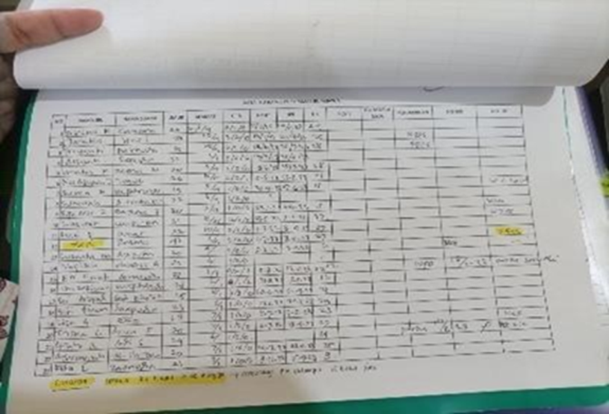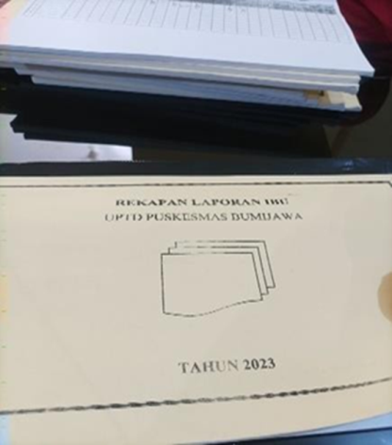

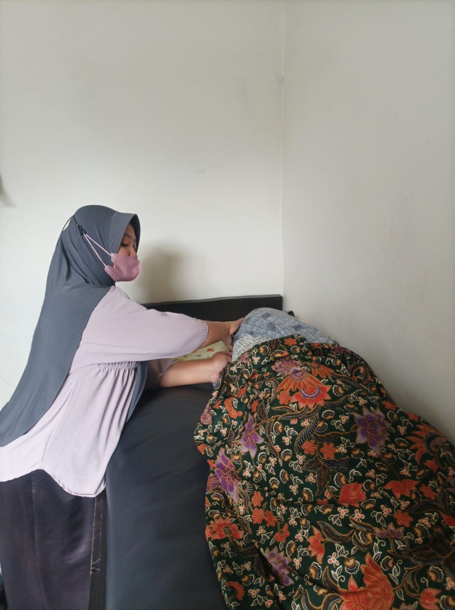

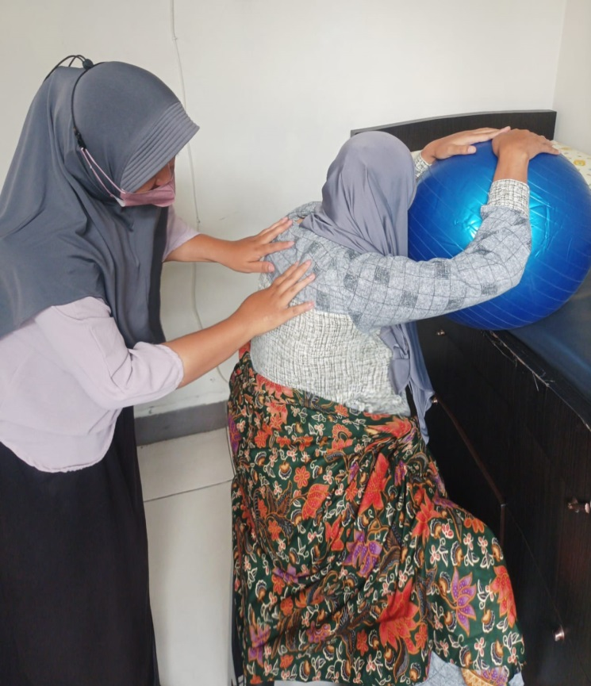

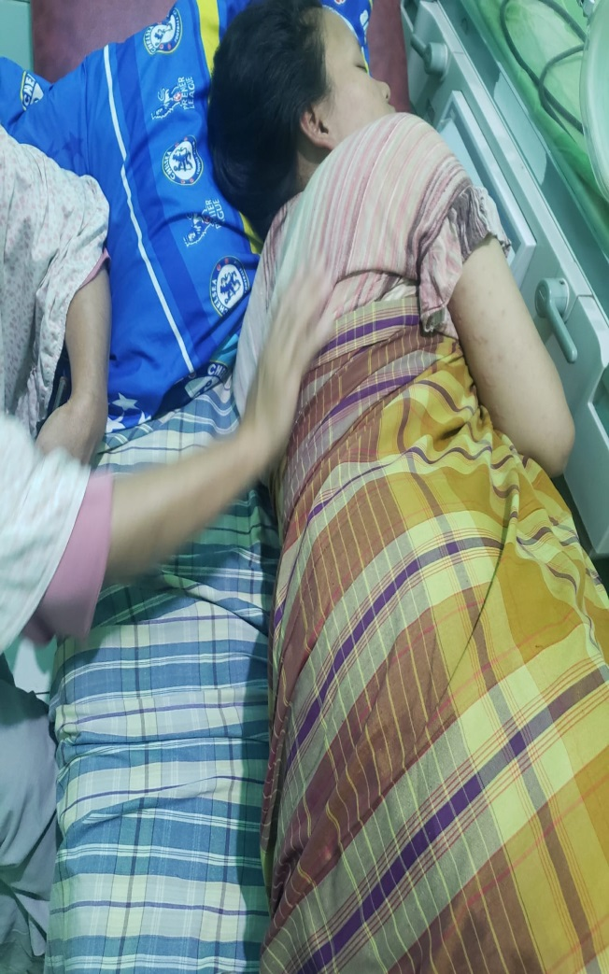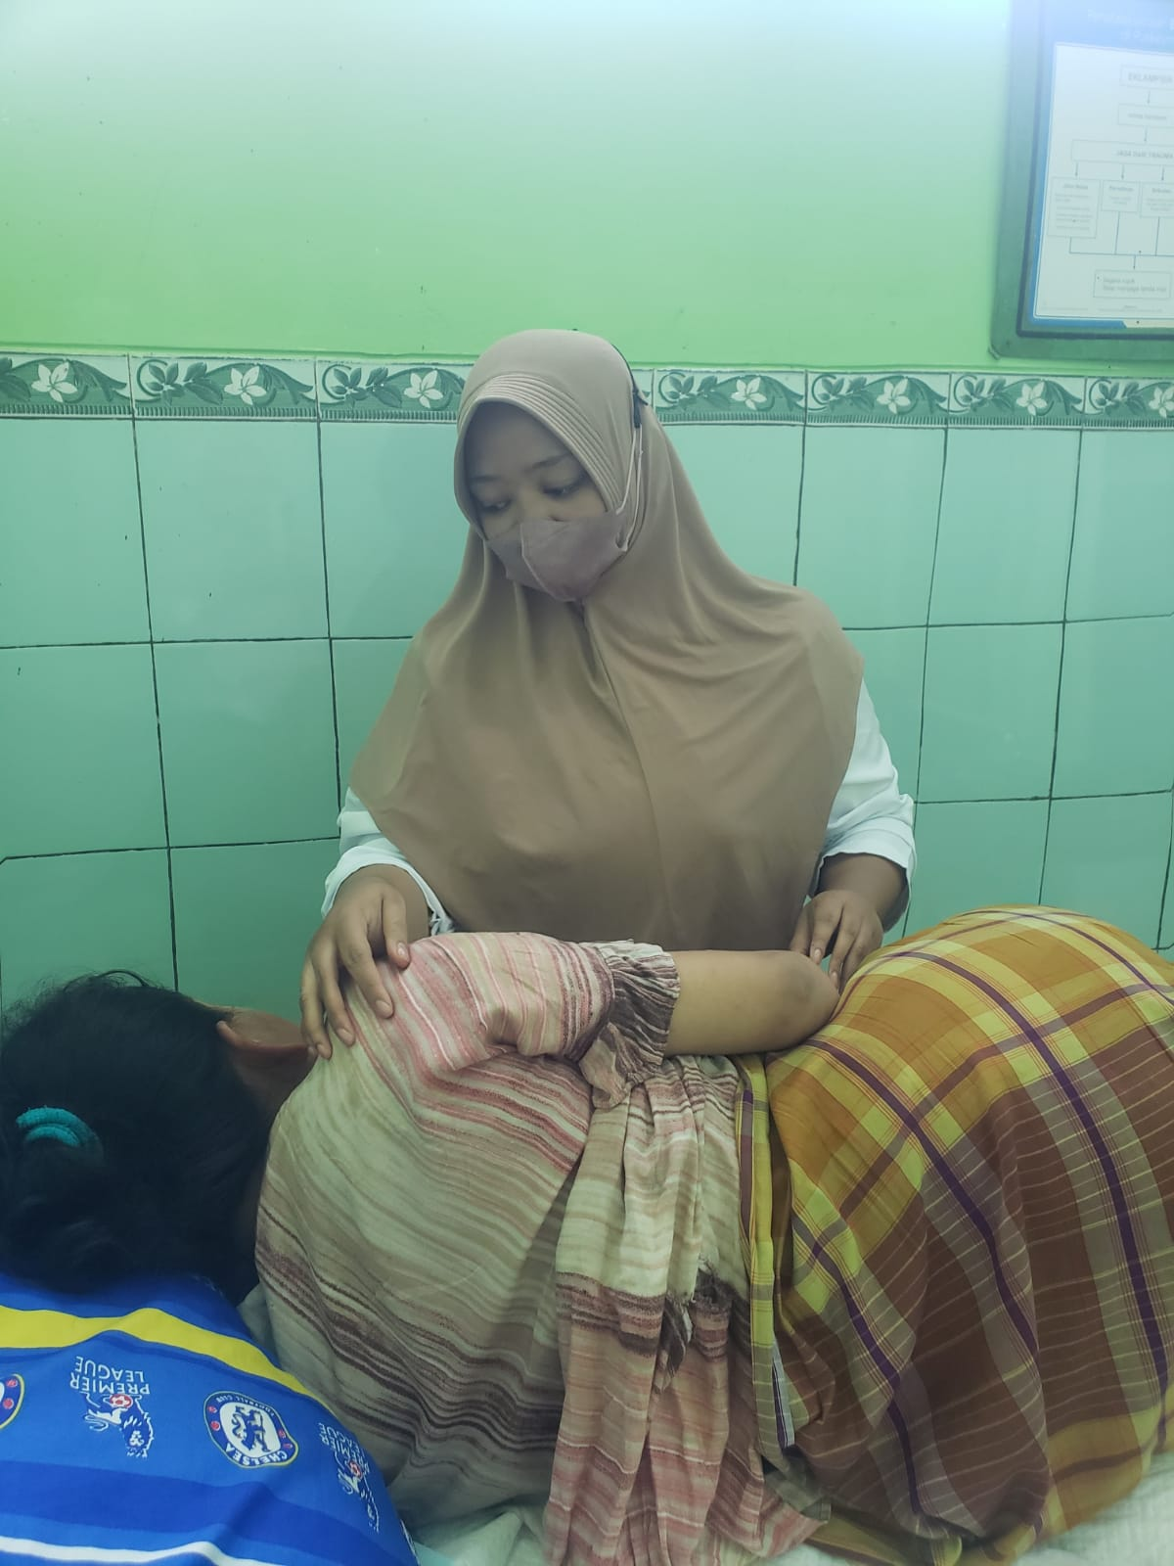

1. Table hasil analisa data dan penelitian
2. **Hasil Karakteristik Responden (Berdasarkan Usia)**

|  |  |  |  |  |  |  |  |  |
| --- | --- | --- | --- | --- | --- | --- | --- | --- |
| **Descriptives** | | | | | | | | |
| **Usia** | | | | | | | | |
|  | N | Mean | Std. Deviation | Std. Error | 95% Confidence Interval for Mean | | Minimum | Maximum |
| Lower Bound | Upper Bound |
| Eksperimen | 30 | 30.1667 | 7.86999 | 1.43686 | 27.2280 | 33.1054 | 18.00 | 45.00 |
| Kontrol | 30 | 28.4667 | 7.27648 | 1.32850 | 25.7496 | 31.1837 | 19.00 | 44.00 |
| Total | 60 | 29.3167 | 7.56327 | .97641 | 27.3629 | 31.2705 | 18.00 | 45.00 |

1. **Hasil Karakteristik Responden (Berdasarkan Paritas)**

**Descriptive**

|  |  |  |  |  |  |
| --- | --- | --- | --- | --- | --- |
| **Paritas * Kelompok Crosstabulation** | | | | | |
|  | | | Kelompok | | Total |
| Eksperimen | Kontrol |
| Paritas | Primipara | Count | 10 | 13 | 23 |
| % within Kelompok | 33.3% | 43.3% | 38.3% |
| Multipara | Count | 16 | 12 | 28 |
| % within Kelompok | 53.3% | 40.0% | 46.7% |
| Grandamultipara | Count | 4 | 5 | 9 |
| % within Kelompok | 13.3% | 16.7% | 15.0% |
| Total | | Count | 30 | 30 | 60 |
| % within Kelompok | 100.0% | 100.0% | 100.0% |

1. **Hasil Karakteristik Responden (Berdasarkan Pendidikan)**

|  |  |  |  |  |  |
| --- | --- | --- | --- | --- | --- |
| **Pendidikan * Kelompok Crosstabulation** | | | | | |
|  | | | Kelompok | | Total |
| Eksperimen | Kontrol |
| Pendidikan | Tidak tamat SD | Count | 2 | 1 | 3 |
| % within Kelompok | 6.7% | 3.3% | 5.0% |
| SD | Count | 7 | 11 | 18 |
| % within Kelompok | 23.3% | 36.7% | 30.0% |
| SMP | Count | 5 | 7 | 12 |
| % within Kelompok | 16.7% | 23.3% | 20.0% |
| SMA | Count | 13 | 8 | 21 |
| % within Kelompok | 43.3% | 26.7% | 35.0% |
| Diploma | Count | 3 | 3 | 6 |
| % within Kelompok | 10.0% | 10.0% | 10.0% |
| Total | | Count | 30 | 30 | 60 |
| % within Kelompok | 100.0% | 100.0% | 100.0% |

1. **Hasil Karakteristik Responden (Berdasarkan Pekerjaan)**

|  |  |  |  |  |  |
| --- | --- | --- | --- | --- | --- |
| **Pekerjaan * Kelompok Crosstabulation** | | | | | |
|  | | | Kelompok | | Total |
| Eksperimen | Kontrol |
| Pekerjaan | MRT | Count | 16 | 19 | 35 |
| % within Kelompok | 53.3% | 63.3% | 58.3% |
| Pedagang | Count | 4 | 4 | 8 |
| % within Kelompok | 13.3% | 13.3% | 13.3% |
| Pengajar | Count | 4 | 1 | 5 |
| % within Kelompok | 13.3% | 3.3% | 8.3% |
| Swasta | Count | 6 | 6 | 12 |
| % within Kelompok | 20.0% | 20.0% | 20.0% |
| Total | | Count | 30 | 30 | 60 |
| % within Kelompok | 100.0% | 100.0% | 100.0% |

1. **Hasil Uji Normalitas**

**Explore** **Kelompok**

|  |  |  |  |  |  |  |  |
| --- | --- | --- | --- | --- | --- | --- | --- |
| **Tests of Normality** | | | | | | | |
|  | Kelompok | Kolmogorov-Smirnova | | | Shapiro-Wilk | | |
|  | Statistic | df | Sig. | Statistic | df | Sig. |
| Pretest | Eksperimen | .237 | 30 | .000 | .868 | 30 | .001 |
| Kontrol | .184 | 30 | .011 | .925 | 30 | .036 |
| Posttest | Eksperimen | .163 | 30 | .041 | .919 | 30 | .025 |
| Kontrol | .206 | 30 | .002 | .937 | 30 | .025 |
| a. Lilliefors Significance Correction | | | | | | | |

1. **Hasil Uji Homogenitas**

|  |  |  |  |  |  |
| --- | --- | --- | --- | --- | --- |
| **Tests of Homogeneity of Variances** | | | | | |
|  | | Levene Statistic | df1 | df2 | Sig. |
| Pretest | Based on Mean | .070 | 1 | 58 | .793 |
| Based on Median | .000 | 1 | 58 | 1.000 |
| Based on Median and with adjusted df | .000 | 1 | 57.599 | 1.000 |
| Based on trimmed mean | .051 | 1 | 58 | .822 |
| Posttest | Based on Mean | .578 | 1 | 58 | .450 |
| Based on Median | .803 | 1 | 58 | .374 |
| Based on Median and with adjusted df | .803 | 1 | 57.995 | .374 |
| Based on trimmed mean | .552 | 1 | 58 | .461 |

1. **Hasil Uji Wilcoxon Experimen**

**NPar Tests**

|  |  |  |  |  |  |
| --- | --- | --- | --- | --- | --- |
| **Descriptive Statistics** | | | | | |
|  | N | Mean | Std. Deviation | Minimum | Maximum |
| Pretest.Exp | 30 | 8.2333 | 1.47819 | 4.00 | 10.00 |
| Posttest.Exp | 30 | 5.1333 | 1.43198 | 3.00 | 8.00 |

**Wilcoxon Signed Ranks Test**

|  |  |  |  |  |
| --- | --- | --- | --- | --- |
| **Ranks** | | | | |
|  | | N | Mean Rank | Sum of Ranks |
| Posttest.Exp - Pretest.Exp | Negative Ranks | 29a | 15.00 | 435.00 |
| Positive Ranks | 0b | .00 | .00 |
| Ties | 1c |  |  |
| Total | 30 |  |  |
| a. Posttest.Exp < Pretest.Exp | | | | |
| b. Posttest.Exp > Pretest.Exp | | | | |
| c. Posttest.Exp = Pretest.Exp | | | | |

|  |  |
| --- | --- |
| **Test Statisticsa** | |
|  | Posttest.Exp - Pretest.Exp |
| Z | -4.741b |
| Asymp. Sig. (2-tailed) | .001 |
| a. Wilcoxon Signed Ranks Test | |
| b. Based on positive ranks. | |

1. **Hasil Uji Wilcoxon Kontrol**

**NPar Tests**

|  |  |  |  |  |  |
| --- | --- | --- | --- | --- | --- |
| **Descriptive Statistics** | | | | | |
|  | N | Mean | Std. Deviation | Minimum | Maximum |
| Pretest.Kon | 30 | 7.7000 | 1.41787 | 4.00 | 10.00 |
| Posttest.Kon | 30 | 6.6667 | 1.24106 | 4.00 | 9.00 |

**Wilcoxon Signed Ranks Test**

|  |  |  |  |  |
| --- | --- | --- | --- | --- |
| **Ranks** | | | | |
|  | | N | Mean Rank | Sum of Ranks |
| Posttest.Kon - Pretest.Kon | Negative Ranks | 21a | 16.76 | 352.00 |
| Positive Ranks | 8b | 10.38 | 83.00 |
| Ties | 1c |  |  |
| Total | 30 |  |  |
| a. Posttest.Kon < Pretest.Kon | | | | |
| b. Posttest.Kon > Pretest.Kon | | | | |
| c. Posttest.Kon = Pretest.Kon | | | | |

|  |  |
| --- | --- |
| **Test Statisticsa** | |
|  | Posttest.Kon - Pretest.Kon |
| Z | -2.960b |
| Asymp. Sig. (2-tailed) | .103 |
| a. Wilcoxon Signed Ranks Test | |
| b. Based on positive ranks. | |

1. **Hasil Deskriptif (Pretest - Posttest)**

**Descriptives**

|  |  |  |  |  |  |
| --- | --- | --- | --- | --- | --- |
| **Descriptive Statistics** | | | | | |
|  | N | Minimum | Maximum | Mean | Std. Deviation |
| Pretest.Exp | 30 | 4.00 | 10.00 | 8.2333 | 1.47819 |
| Posttest.Exp | 30 | 3.00 | 8.00 | 5.1333 | 1.43198 |
| Valid N (listwise) | 30 |  |  |  |  |

**Descriptives**

|  |  |  |  |  |  |
| --- | --- | --- | --- | --- | --- |
| **Descriptive Statistics** | | | | | |
|  | N | Minimum | Maximum | Mean | Std. Deviation |
| Pretest.Kon | 30 | 4.00 | 10.00 | 7.7000 | 1.41787 |
| Posttest.Kon | 30 | 4.00 | 9.00 | 6.6667 | 1.24106 |
| Valid N (listwise) | 30 |  |  |  |  |

1. **Hasil Uji Mann Whitney (Experimen – Kontrol)**

**NPar Tests**

|  |  |  |  |  |  |
| --- | --- | --- | --- | --- | --- |
| **Descriptive Statistics** | | | | | |
|  | N | Mean | Std. Deviation | Minimum | Maximum |
| Pretest | 60 | 7.9667 | 1.46098 | 4.00 | 10.00 |
| Posttest | 60 | 5.9000 | 1.53711 | 3.00 | 9.00 |
| Kelompok | 60 | 1.5000 | .50422 | 1.00 | 2.00 |

**Mann-Whitney Test**

|  |  |  |  |  |
| --- | --- | --- | --- | --- |
| **Ranks** | | | | |
|  | Kelompok | N | Mean Rank | Sum of Ranks |
| Pretest | Eksperimen | 30 | 34.08 | 1022.50 |
| Kontrol | 30 | 26.92 | 807.50 |
| Total | 60 |  |  |
| Posttest | Eksperimen | 30 | 22.07 | 662.00 |
| Kontrol | 30 | 38.93 | 1168.00 |
| Total | 60 |  |  |

|  |  |  |
| --- | --- | --- |
| **Test Statisticsa** | | |
|  | Pretest | Posttest |
| Mann-Whitney U | 342.500 | 197.000 |
| Wilcoxon W | 807.500 | 662.000 |
| Z | -1.635 | -3.819 |
| Asymp. Sig. (2-tailed) | .102 | .001 |
| a. Grouping Variable: Kelompok | | |

1. **Hasil Deskriptif Delta (Experimen - Kontrol)**

**Descriptive**

|  |  |  |  |  |  |  |  |  |
| --- | --- | --- | --- | --- | --- | --- | --- | --- |
| **Descriptives** | | | | | | | | |
| DltPre_Post | | | | | | | | |
|  | N | Mean | Std. Deviation | Std. Error | 95% Confidence Interval for Mean | | Minimum | Maximum |
| Lower Bound | Upper Bound |
| Eksperimen | 30 | 3.1000 | 1.56139 | .28507 | 2.5170 | 3.6830 | .00 | 7.00 |
| Kontrol | 30 | 1.0333 | 1.65015 | .30127 | .4172 | 1.6495 | -2.00 | 4.00 |
| Total | 60 | 2.0667 | 1.90331 | .24572 | 1.5750 | 2.5583 | -2.00 | 7.00 |

1. **Hasil Uji Mann Whitney Delta (Experimen - Kontrol)**

**NPar Tests**

**NPar Tests**

**Mann-Whitney Test**

|  |  |  |  |  |
| --- | --- | --- | --- | --- |
| **Ranks** | | | | |
|  | Kelompok | N | Mean Rank | Sum of Ranks |
| DltPre_Post | Eksperimen | 30 | 39.90 | 1197.00 |
| Kontrol | 30 | 21.10 | 633.00 |
| Total | 60 |  |  |

|  |  |
| --- | --- |
| **Test Statisticsa** | |
|  | DltPre_Post |
| Mann-Whitney U | 168.000 |
| Wilcoxon W | 633.000 |
| Z | -4.237 |
| Asymp. Sig. (2-tailed) | .001 |
| a. Grouping Variable: Kelompok | |